Networking:

Network Management

1.Sevan Layers of Open System Interconnection(OSI) Model
Ans: If network communications need to happen with out any trouble, many problems must be solved. In 1977 the International Standards Organization (ISO) proposed the Open Systems Interconnection (OSI) network model. The Open Systems Interconnection (OSI) model breaks down the problems involved in moving data from one computer to another computer. Open Systems Interconnection (OSI) model categorizes these hundreds of problems to Seven Layers. A layer in Open Systems Interconnection (OSI) model is a portion that is used to categorize specific problems.

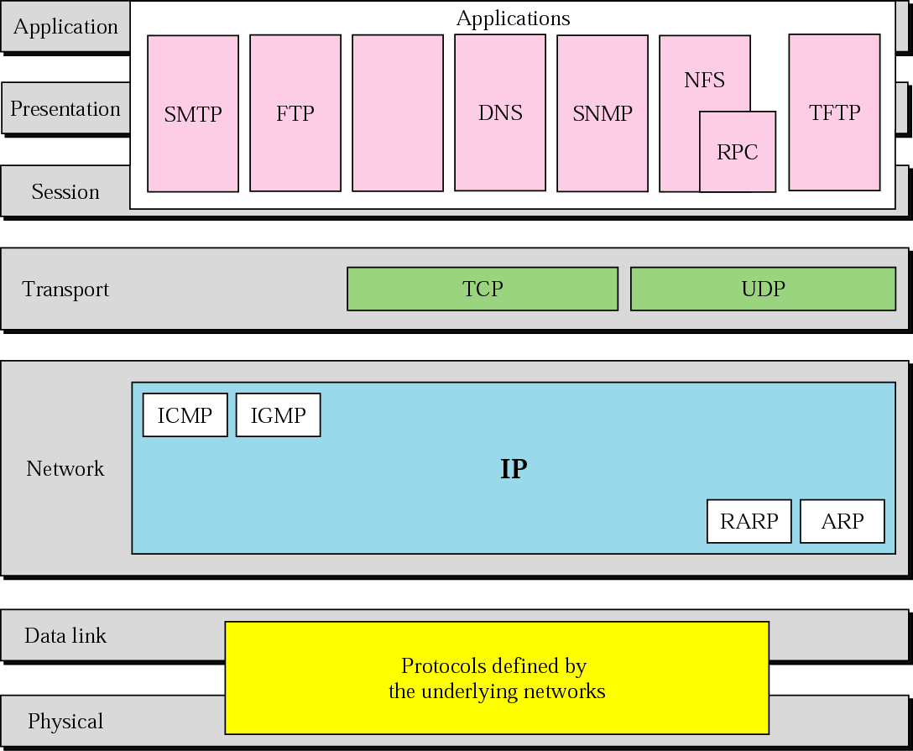
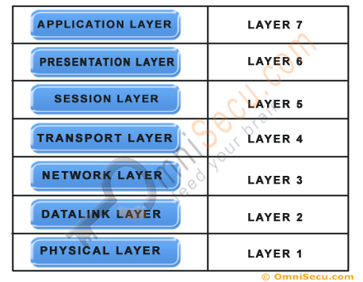

- Layer 1. Physical Layer
The first layer of the seven layers of Open Systems Interconnection (OSI) network model is called the Physical layer. Physical circuits are created on the physical layer of Open Systems Interconnection (OSI) model. Physical layers describe the electrical or optical signals used for communication. Physical layer of the Open Systems Interconnection (OSI) model is only concerned with the physical characteristics of electrical or optical signaling techniques which includes the voltage of the electrical current used to transport the signal, the media type (Twisted Pair, Coaxial Cable, Optical Fiber etc), impedance characteristics, physical shape of the connector, Synchronization etc. The Physical Layer is limited to the processes needed to place the communication signals over the media, and to receive signals coming from that media. The lower boundary of the physical layer of the Open Systems Interconnection (OSI) model is the physical connector attached to the transmission media. Physical layer of the Open Systems Interconnection (OSI) model does not include the transmission media. Transmission media stays outside the scope of the Physical Layer and are also referred to as Layer 0 of the Open Systems Interconnection (OSI) Model.

Layer 2. Datalink Layer
The second layer of the seven layers of Open Systems Interconnection (OSI) network model is called the Datalink layer. The Data Link layer resides above the Physical layer and below the Network layer. Datalink layer is responsible for providing end-to-end validity of the data being transmitted. The Data Link Layer is logically divided into two sublayers, The Media Access Control (MAC) Sublayer and the Logical Link Control (LLC) Sublayer.
Media Access Control (MAC) Sublayer determines the physical addressing of the hosts. The MAC sub-layer maintains MAC addresses (physical device addresses) for communicating with other devices on the network. MAC addresses are burned into the network cards and constitute the low-level address used to determine the source and destination of network traffic. MAC Addresses are also known as Physical addresses, Layer 2 addresses, or Hardware addresses.
The Logical Link Control sublayer is responsible for synchronizing frames, error checking, and flow control.

Layer 3. Network Layer
The third layer of the seven layers of Open Systems Interconnection (OSI) network model is the Network layer. The Network layer of the OSI model is responsible for managing logical addressing information in the packets and the delivery of those packets to the correct destination. Routers, which are special computers used to build the network, direct the data packet generated by Network Layer using information stored in a table known as routing table. The routing table is a list of available destinations that are stored in memory on the routers. The network layer is responsible for working with logical addresses. The logical addresses are used to uniquely identify a computer on the network, but at the same time identify the network that system resides on. The logical address is used by network layer protocols to deliver the packets to the correct network. The Logical addressing system used in Network Layer is known as IP address.
IP addresses are also known as Logical addresses or Layer 3 addresses.

Layer 4. Transport Layer
The fourth layer of the seven layers of Open Systems Interconnection (OSI) network mode is the Transport layer. The Transport layer handles transport functions such as reliable or unreliable delivery of the data to the destination. On the sending computer, the transport layer is responsible for breaking the data into smaller packets, so that if any packet is lost during transmission, the missing packets will be sent again. Missing packets are determined by acknowledgments (ACKs) from the remote device, when the remote device receives the packets. At the receiving system, the transport layer will be responsible for opening all of the packets and reconstructing the original message.
Another function of the transport layer is TCP segment sequencing. Sequencing is a connection-oriented service that takes TCP segments that are received out of order and place them in the right order.
The transport layer also enables the option of specifying a "service address" for the services or application on the source and the destination computer to specify what application the request came from and what application the request is going to.
Many network applications can run on a computer simultaneously and there should be some mechanism to identify which application should receive the incoming data. To make this work correctly, incoming data from different applications are multiplexed at the Transport layer and sent to the bottom layers. On the other side of the communication, the data received from the bottom layers are de-multiplexed at the Transport layer and delivered to the correct application. This is achieved by using "Port Numbers".
The protocols operating at the Transport Layer, TCP (Transmission Control Protocol) and UDP (User Datagram Protocol) uses a mechanism known as "Port Number" to enable multiplexing and de-multiplexing. Port numbers identify the originating network application on the source computer and destination network application on the receiving computer.

Layer 5. Session Layer
The position of Session Layer of the Seven Layered Open Systems Interconnection (OSI) model is between Transport Layer and the Presentation Layer. Session layer is the fifth layer of seven layered Open Systems Interconnection (OSI) Model. The session layer is responsible for establishing, managing, and terminating connections between applications at each end of the communication.
In the connection establishment phase, the service and the rules (who transmits and when, how much data can be sent at a time etc.) for communication between the two devices are proposed. The participating devices must agree on the rules. Once the rules are established, the data transfer phase begins. Connection termination occurs when the session is complete, and communication ends gracefully.
In practice, Session Layer is often combined with the Transport Layer.

Layer 6. Presentation Layer
The position of Presentation Layer in seven layered Open Systems Interconnection (OSI) model is just below the Application Layer. When the presentation layer receives data from the application layer, to be sent over the network, it makes sure that the data is in the proper format. If it is not, the presentation layer converts the data to the proper format. On the other side of communication, when the presentation layer receives network data from the session layer, it makes sure that the data is in the proper format and once again converts it if it is not.
Formatting functions at the presentation layer may include compression, encryption, and ensuring that the character code set (ASCII, Unicode, EBCDIC (Extended Binary Coded Decimal Interchange Code, which is used in IBM servers) etc) can be interpreted on the other side.
For example, if we select to compress the data from a network application that we are using, the Application Layer will pass that request to the Presentation Layer, but it will be the Presentation Layer that does the compression.

Layer 7. Application Layer
The Application Layer the seventh layer in OSI network model. Application Layer is the top-most layer of the seven layered Open Systems Interconnection (OSI) network model. Real traffic data will be often generated from the Application Layer. This may be a web request generated from HTTP protocol, a command from telnet protocol, a file download request from FTP protocol etc.
In this lesson (Seven Layers of Open Systems Interconnection (OSI) Model), you have learned what are the Seven Layers of Open Systems Interconnection (OSI) Model and the functions of these seven layers. The top-most layer of the Seven Layers of Open Systems Interconnection (OSI) Model is the Application Layer and the bottom-most layer of the Seven Layers of Open Systems Interconnection (OSI) Model is Physical Layer. Click "Next" to Continue.

2.What is TCP/IP model of networking and what is UDP/IP model of networking?
Also note the differences between them.
Ans:
TCP/IP means Transmission Control Protocol and Internet Protocol. It is the network model used in the current Internet architecture as well. Protocols are set of rules which govern every possible communication over a network. These protocols describe the movement of data between the source and destination or the internet. These protocols offer simple naming and addressing schemes.

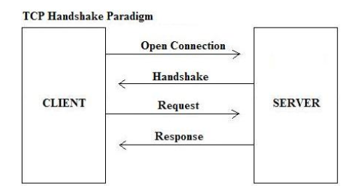

What udp/Ip model

UDP is a connectionless and unreliable transport protocol.The two ports serve to identify the end points within the source and destination machines. User Datagram Protocol is used, in place of TCP, when a reliable delivery is not required.However, UDP is never used to send important data such as web-pages, database information, etc. Streaming media such as video,audio and others use UDP because it offers speed.

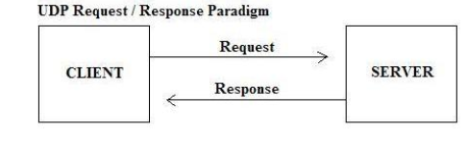

Also note the differences between them?

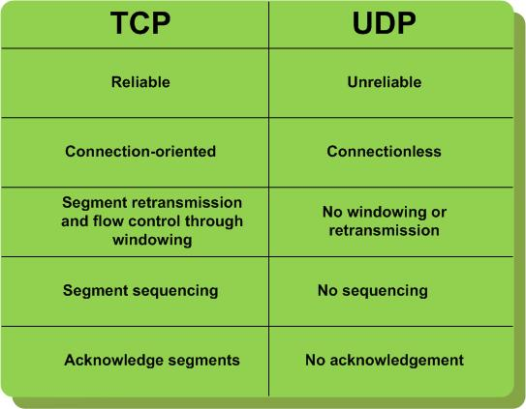

3. How OSI is different from 4 layer TCP/IP model

OSI(Open System Interconnection) TCP/IP(Transmission Control Protocol / Internet Protocol)
1. OSI is a generic, protocol independent standard, acting as a communication gateway between the network and end user.
1. TCP/IP model is based on standard protocols around which the Internet has developed. It is a communication protocol, which allows connection of hosts over a network.
2. In OSI model the transport layer guarantees the delivery of packets.
2. In TCP/IP model the transport layer does not guarantees delivery of packets. Still the TCP/IP model is more reliable.
3. Follows vertical approach.
3. Follows horizontal approach.
4. OSI model has a separate Presentation layer and Session layer.
4. TCP/IP does not have a separate Presentation layer or Session layer.
5. OSI is a reference model around which the networks are built.
Generally it is used as a guidance tool.
5. TCP/IP model is, in a way implementation of the OSI model.
6. Network layer of OSI model provides both connection oriented and connectionless service.
6. The Network layer in TCP/IP model provides connectionless service.
7. OSI model has a problem of fitting the protocols into the model.
7. TCP/IP model does not fit any protocol
8. Protocols are hidden in OSI model and are easily replaced as the technology changes.
8. In TCP/IP replacing protocol is not easy.
9. OSI model defines services, interfaces and protocols very clearly and makes clear distinction between them. It is protocol independent.
9. In TCP/IP, services, interfaces and protocols are not clearly separated. It is also protocol dependent.
10. It has 7 layers
10. It has 4 layers

4. What are different networking protocols?

Rules of Network Protocol include guidelines that regulate the following characteristics of a network: access method, allowed physical topologies, types of cabling, and speed of data transfer.
Types of Network Protocols

The most common network protocols are:

Ethernet
Local Talk
Token Ring
FDDI
ATM

The followings are some commonly used network symbols to draw different kinds of network protocols.

Types of Network Protocols

Ethernet

The Ethernet protocol is by far the most widely used one. Ethernet uses an access method called CSMA/CD (Carrier Sense Multiple Access/Collision Detection). This is a system where each computer listens to the cable before sending anything through the network. If the network is clear, the computer will transmit. If some other nodes have already transmitted on the cable, the computer will wait and try again when the line is clear. Sometimes, two computers attempt to transmit at the same instant. A collision occurs when this happens. Each computer then backs off and waits a random amount of time before attempting to retransmit. With this access method, it is normal to have collisions. However, the delay caused by collisions and retransmitting is very small and does not normally effect the speed of transmission on the network.

The Ethernet protocol allows for linear bus, star, or tree topologies. Data can be transmitted over wireless access points, twisted pair, coaxial, or fiber optic cable at a speed of 10 Mbps up to 1000 Mbps.

Fast Ethernet

To allow for an increased speed of transmission, the Ethernet protocol has developed a new standard that supports 100 Mbps. This is commonly called Fast Ethernet. Fast Ethernet requires the application of different, more expensive network concentrators/hubs and network interface cards. In addition, category 5 twisted pair or fiber optic cable is necessary. Fast Ethernet is becoming common in schools that have been recently wired.

Local Talk

Local Talk is a network protocol that was developed by Apple Computer, Inc. for Macintosh computers. The method used by Local Talk is called CSMA/CA (Carrier Sense Multiple Access with Collision Avoidance). It is similar to CSMA/CD except that a computer signals its intent to transmit before it actually does so. Local Talk adapters and special twisted pair cable can be used to connect a series of computers through the serial port. The Macintosh operating system allows the establishment of a peer-to-peer network without the need for additional software. With the addition of the server version of AppleShare software, a client/server network can be established.

The Local Talk protocol allows for linear bus, star, or tree topologies using twisted pair cable. A primary disadvantage of Local Talk is low speed. Its speed of transmission is only 230 Kbps.

Token Ring

The Token Ring protocol was developed by IBM in the mid-1980s. The access method used involves token-passing. In Token Ring, the computers are connected so that the signal travels around the network from one computer to another in a logical ring. A single electronic token moves around the ring from one computer to the next. If a computer does not have information to transmit, it simply passes the token on to the next workstation. If a computer wishes to transmit and receives an empty token, it attaches data to the token. The token then proceeds around the ring until it comes to the computer for which the data is meant. At this point, the data is captured by the receiving computer. The Token Ring protocol requires a star-wired ring using twisted pair or fiber optic cable. It can operate at transmission speeds of 4 Mbps or 16 Mbps. Due to the increasing popularity of Ethernet, the use of Token Ring in school environments has decreased.

FDDI

Fiber Distributed Data Interface (FDDI) is a network protocol that is used primarily to interconnect two or more local area networks, often over large distances. The access method used by FDDI involves token-passing. FDDI uses a dual ring physical topology. Transmission normally occurs on one of the rings; however, if a break occurs, the system keeps information moving by automatically using portions of the second ring to create a new complete ring. A major advantage of FDDI is high speed. It operates over fiber optic cable at 100 Mbps.

ATM

Asynchronous Transfer Mode (ATM) is a network protocol that transmits data at a speed of 155 Mbps and higher. ATM works by transmitting all data in small packets of a fixed size; whereas, other protocols transfer variable length packets. ATM supports a variety of media such as video, CD-quality audio, and imaging. ATM employs a star topology, which can work with fiber optic as well as twisted pair cable.

ATM is most often used to interconnect two or more local area networks. It is also frequently used by Internet Service Providers to utilize high-speed access to the Internet for their clients. As ATM technology becomes more cost-effective, it will provide another solution for constructing faster local area networks.

Gigabit Ethernet

The most latest development in the Ethernet standard is a protocol that has a transmission speed of 1 Gbps. Gigabit Ethernet is primarily used for backbones on a network at this time. In the future, it will probably also be used for workstation and server connections. It can be used with both fiber optic cabling and copper. The 1000BaseTX, the copper cable used for Gigabit Ethernet, became the formal standard in 1999.

5. Why do we have MAC and IP addresses?

6. What are different types of topologies viz., bus, ring, star, mesh

Types of Network Topology

Network Topology is the schematic description of a network arrangement, connecting various nodes(sender and receiver) through lines of connection.
BUS Topology

Bus topology is a network type in which every computer and network device is connected to single cable. When it has exactly two endpoints, then it is called Linear Bus topology.
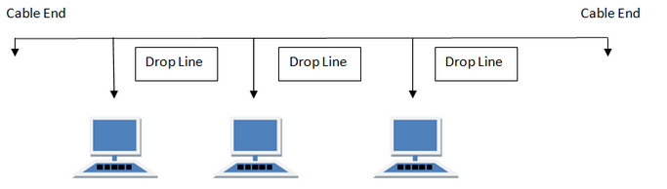

Bus topology in computer networks
Features of Bus Topology

It transmits data only in one direction.
Every device is connected to a single cable

Advantages of Bus Topology

It is cost effective.
Cable required is least compared to other network topology.
Used in small networks.
It is easy to understand.
Easy to expand joining two cables together.

Disadvantages of Bus Topology

Cables fails then whole network fails.
If network traffic is heavy or nodes are more the performance of the network decreases.
Cable has a limited length.
It is slower than the ring topology.

RING Topology

It is called ring topology because it forms a ring as each computer is connected to another computer, with the last one connected to the first. Exactly two neighbours for each device.

Ring topology in computer networks
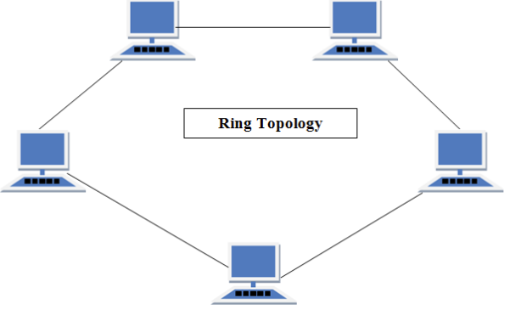
Features of Ring Topology

A number of repeaters are used for Ring topology with large number of nodes, because if someone wants to send some data to the last node in the ring topology with 100 nodes, then the data will have to pass through 99 nodes to reach the 100th node. Hence to prevent data loss repeaters are used in the network.
The transmission is unidirectional, but it can be made bidirectional by having 2 connections between each Network Node, it is called Dual Ring Topology.
In Dual Ring Topology, two ring networks are formed, and data flow is in opposite direction in them. Also, if on7. What is meant by socket?e ring fails, the second ring can act as a backup, to keep the network up.
Data is transferred in a sequential manner that is bit by bit. Data transmitted, has to pass through each node of the network, till the destination node.

Advantages of Ring Topology

Transmitting network is not affected by high traffic or by adding more nodes, as only the nodes having tokens can transmit data.
Cheap to install and expand

Disadvantages of Ring Topology

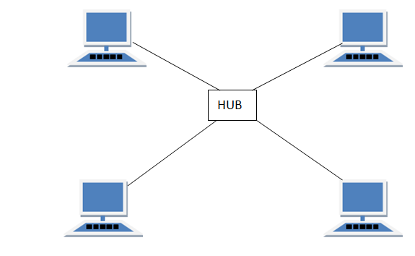
Troubleshooting is difficult in ring topology.
Adding or deleting the computers disturbs the network activity.
Failure of one computer disturbs the whole network.

STAR Topology

In this type of topology all the computers are connected to a single hub through a cable. This hub is the central node and all others nodes are connected to the central node.

Star topology in computer networks

Features of Star Topology

Every node has its own dedicated connection to the hub.
Hub acts as a repeater for data flow.
Can be used with twisted pair, Optical Fibre or coaxial cable.

Advantages of Star Topology

Fast performance with few nodes and low network traffic.
Hub can be upgraded easily.
Easy to troubleshoot.
Easy to setup and modify.
Only that node is affected which has failed, rest of the nodes can work smoothly.

Disadvantages of Star Topology

Cost of installation is high.
Expensive to use.
If the hub fails then the whole network is stopped because all the nodes depend on the hub.
Performance is based on the hub that is it depends on its capacity

MESH Topology

It is a point-to-point connection to other nodes or devices. All the network nodes are connected to each other. Mesh has n(n-1)/2 physical channels to link n devices.

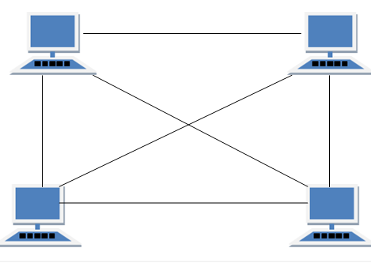

There are two techniques to transmit data over the Mesh topology, they are :

Routing
Flooding

Routing

In routing, the nodes have a routing logic, as per the network requirements. Like routing logic to direct the data to reach the destination using the shortest distance. Or, routing logic which has information about the broken links, and it avoids those node etc. We can even have routing logic, to re-configure the failed nodes.
Flooding

In flooding, the same data is transmitted to all the network nodes, hence no routing logic is required. The network is robust, and the its very unlikely to lose the data. But it leads to unwanted load over the network.

Mesh topology in computer networks
Types of Mesh Topology

Partial Mesh Topology : In this topology some of the systems are connected in the same fashion as mesh topology but some devices are only connected to two or three devices.
Full Mesh Topology : Each and every nodes or devices are connected to each other.

Features of Mesh Topology

Fully connected.
Robust.
Not flexible.

Advantages of Mesh Topology

Each connection can carry its own data load.
It is robust.
Fault is diagnosed easily.
Provides security and privacy.

Disadvantages of Mesh Topology

Installation and configuration is difficult.
Cabling cost is more.
Bulk wiring is required.

TREE Topology

It has a root node and all other nodes are connected to it forming a hierarchy. It is also called hierarchical topology. It should at least have three levels to the hierarchy.
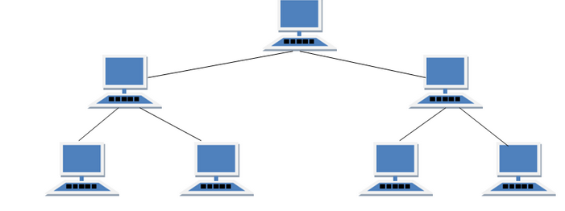

Tree topology in computer networks
Features of Tree Topology

Ideal if workstations are located in groups.
Used in Wide Area Network.

Advantages of Tree Topology

Extension of bus and star topologies.
Expansion of nodes is possible and easy.
Easily managed and maintained.
Error detection is easily done.

Disadvantages of Tree Topology

Heavily cabled.
Costly.
If more nodes are added maintenance is difficult.
Central hub fails, network fails.

HYBRID Topology

It is two different types of topologies which is a mixture of two or more topologies. For example if in an office in one department ring topology is used and in another star topology is used, connecting these topologies will result in Hybrid Topology (ring topology and star topology).

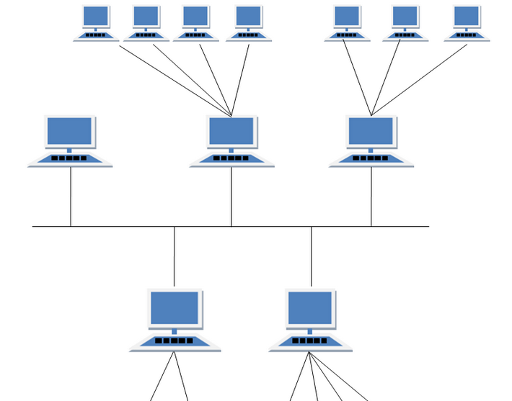
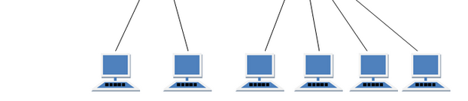

Hybrid topology in computer networks
Features of Hybrid Topology

It is a combination of two or topologies
Inherits the advantages and disadvantages of the topologies included

Advantages of Hybrid Topology

Reliable as Error detecting and trouble shooting is easy.
Effective.

7. What is meant by socket?
Normally, a server runs on a specific computer and has a socket that is bound to a specific port number. The server just waits, listening to the socket for a client to make a connection request.

On the client-side: The client knows the hostname of the machine on which the server is running and the port number on which the server is listening. To make a connection request, the client tries to rendezvous with the server on the server's machine and port. The client also needs to identify itself to the server so it binds to a local port number that it will use during this connection. This is usually assigned by the system.
A client's connection request
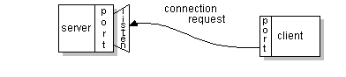

If everything goes well, the server accepts the connection. Upon acceptance, the server gets a new socket bound to the same local port and also has its remote endpoint set to the address and port of the client. It needs a new socket so that it can continue to listen to the original socket for connection requests while tending to the needs of the connected client.
The connection is made
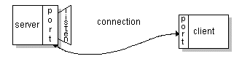

On the client side, if the connection is accepted, a socket is successfully created and the client can use the socket to communicate with the server.

The client and server can now communicate by writing to or reading from their sockets.
Definition:

A socket is one endpoint of a two-way communication link between two programs running on the network. A socket is bound to a port number so that the TCP layer can identify the application that data is destined to be sent to.

8. Explain TCP and UDP headers
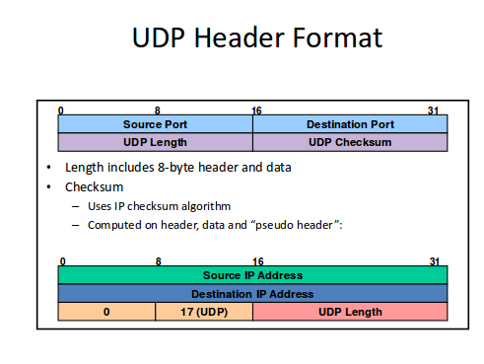

User Datagram Protocol (UDP)
Thin wrapper around IP services
• Service Model

Unreliable unordered datagram service
– Addresses multiplexing of multiple connections
• Multiplexing
–16-bit
port numbers
(some are “well-known”)
• Checksum
–
Validate header
–
Optional in IPv4
–
Mandatory in Ipv6

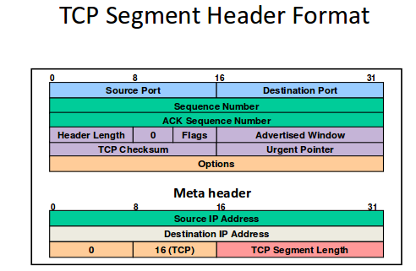

TCP Segment Header Format

16-bit source and destination ports
32-bit send and ACK sequence numbers
4-bit header length(unit = 32 bits)
– Minimum 5 (20 bytes)
– Used as offset to first data byte
• 6×1-bit flags
– URG: *Segment contains urgent data
– ACK: ACK sequence number is valid
– PSH: *Do not delay delivery of data
– RST: Reset connection (reject or abn. termination)
– SYN: Synchronize segment for setup
– FIN: Final segment for teardo

9. Explain the purpose of CRC/checksum

1 down vote accepted

CRC stands for Cyclic Redundancy Check. it helps in error detection.. It consists of the following
The cyclic redundancy check (CRC) is a technique used to detect errors in digital data. CRC is a hash function that detects accidental changes to raw computer data commonly used in digital telecommunications networks and storage devices such as hard disk drives. This technique was invented by W. Wesley Peterson in 1961 and further developed by the CCITT (Comité Consultatif International Telegraphique et Telephonique). Cyclic redundancy checks are quite simple to implement in hardware and can be easily analyzed mathematically. It is one of the better techniques in detecting common transmission errors.
b(x)-> transmitted code word
q(x)-> quotient
i(x)-> information polynomial
r(x)-> remainder polynomial
g(x)-> generated polynomial

step 1: x^(n-k) * i(x)

step 2: r(x) = (x^(n-k) * i(x))%g(x)

step 3: b(x) = (x^(n-k) * i(x)) XOR with r(x)
which results in a transmitted code word.

this b(x) is send to the reciever end from the sender and if u divide the
transmitted code word i.e. b(x) with g(x) and if the remainder
i.e. r(x) is equal to 0 at the reciever end then there is no error
otherwise there is an error in the transmitted code word during the
transmission from sender to reciever.

In this way it is helpful in error detection.

10. Work on the network commands netstat, net,

The netstat command generates displays that show network status and protocol statistics. You can display the status of TCP, SCTP, and UDP endpoints in table format. You can also display routing table information and interface information.

The netstat command displays various types of network data, depending on the selected command-line option. These displays are the most useful for system administration. The basic syntax for netstat follows:

netstat [-m] [-n] [-s] [-i | -r] [-faddress-family]

This section describes the most commonly used options of the netstat command. For a detailed description of all netstat options, refer to the netstat(1M) man page

